Tema 1

Am reusit sa fac un sistem distribuit care creaza si inchide conexiuni, rezerva locurile de autobus pentru utilizatori si listeaza pozitiile libere

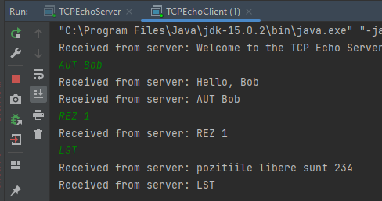

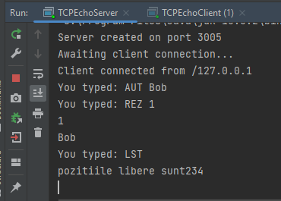

SERVER

package org.example;  
  
import java.net.\*;  
import java.io.\*;  
  
public class TCPEchoServer {  
 public static void main(String args[]) {  
 int[] rezervat = {0, 0, 0, 0, 0};  
 String Persoana = "";  
 String loc;  
 String [] initiala=new String[rezervat.length];  
 int port = 3005;  
 ServerSocket serverSocket = null;  
 DataInputStream dataInputStream = null;  
 DataOutputStream dataOutputStream = null;  
 try {  
// open a server socket  
 serverSocket = new ServerSocket(port);  
 System.*out*.println("Server created on port " + port);  
 System.*out*.println("Awaiting client connection...");  
// await for a client connection  
 Socket clientSocket = serverSocket.accept();  
 System.*out*.println("Client connected from " + clientSocket.getInetAddress());  
 dataInputStream = new DataInputStream(clientSocket.getInputStream());  
 dataOutputStream = new DataOutputStream(clientSocket.getOutputStream());  
 } catch (IOException e) {  
 System.*out*.println("Problems initializing server: " + e);  
 System.*exit*(1);  
 }  
// communicate with the client  
 try {  
 dataOutputStream.writeUTF("Welcome to the TCP Echo Server!");  
 String input;  
 while (true) {  
// read data in from client  
 input = dataInputStream.readUTF();  
  
  
 System.*out*.println("You typed: " + input);  
 if (input.indexOf("AUT ") == 0) {  
 Persoana = input.substring(4);  
 dataOutputStream.writeUTF("Hello, " + Persoana);  
 } else if (input.indexOf("REZ ") == 0) {  
 loc = input.substring(4);  
 rezervat[Integer.*parseInt*(loc)] = 1;  
 initiala[Integer.*parseInt*(loc)]=Persoana;  
 System.*out*.println(rezervat[Integer.*parseInt*(loc)]);  
 System.*out*.println(initiala[Integer.*parseInt*(loc)]);  
  
 } else if (input.equals("BYE")) {  
 dataOutputStream.writeUTF("You disconected from server");  
 dataInputStream.close();  
 dataOutputStream.close();  
 serverSocket.close();  
 } else if (input.equals("LST")) {  
 int poz = 0;  
 for (int i = 0; i < rezervat.length; i++) {  
 if (rezervat[i] == 0)  
 poz = poz \* 10 + i;  
 }  
 dataOutputStream.writeUTF("pozitiile libere sunt " + poz);  
 System.*out*.println("pozitiile libere sunt" + poz);  
  
 }  
  
  
// write data back to client  
 dataOutputStream.writeUTF(input);  
  
  
 }  
 } catch (IOException e) {  
 System.*out*.println("Client disconnected from server");  
 }  
 try {  
 serverSocket.close();  
 } catch (Exception e) {  
 }  
 }  
}

CLIENT

package org.example;  
  
import java.net.\*;  
import java.io.\*;  
  
class TCPEchoReader extends Thread {  
 public TCPEchoReader(DataInputStream input) {  
 dataInputStream = input;  
 active = true;  
 }  
  
 public void run() {  
 while (active) {  
 try {  
 String message = dataInputStream.readUTF();  
 System.*out*.println("Received from server: " + message);  
 } catch (IOException e) {  
 System.*out*.println(e);  
 active = false;  
 }  
 }  
 }  
  
 public boolean active;  
 public DataInputStream dataInputStream;  
}  
  
public class TCPEchoClient {  
 public static void main(String[] args) {  
 String address = "localhost";  
 int port = 3005;  
 Socket socket = null;  
 DataInputStream dataInputStream = null;  
 DataOutputStream dataOutputStream = null;  
 BufferedReader keyboardReader = null;  
// Connect to the server...  
 try {  
 socket = new Socket(address, port);  
// Obtain the streams...  
 dataInputStream = new DataInputStream(socket.getInputStream());  
 dataOutputStream = new DataOutputStream(socket.getOutputStream());  
 keyboardReader = new BufferedReader(new InputStreamReader(System.*in*));  
 } catch (IOException e) {  
 System.*out*.println("Problems initialising: " + e);  
 System.*exit*(1);  
 }  
 try {  
// Start the listening thread...  
 TCPEchoReader reader = new TCPEchoReader(dataInputStream);  
 reader.setDaemon(true);  
 reader.start();  
 String input;  
 while (true) {  
// read data in from the keyboard  
 input = keyboardReader.readLine();  
// send data to server  
 dataOutputStream.writeUTF(input);  
 }  
 } catch (IOException e) {  
 }  
 try {  
 socket.close();  
 } catch (IOException e) {  
 }  
 }  
}